|  |  |
| --- | --- |
| **Name** | Muhammad Arslan Raza |
| **Section** | A |
| **Roll #** | 2020-EE-403 |

**Lab 2**

**Experiment no. 3**

**Observe the Working Principle of Four Stroke Diesel Engine/Compression Ignition**

Diesel engine may be designed as either two stroke or four stroke cycles.

* **A Four Stroke Diesel Engine** is an internal combustion engine in which the piston completes four separate strokes while turning a crankshaft. A stroke refers to the full travel of the piston along the cylinder, in either direction.

**Introduction:**

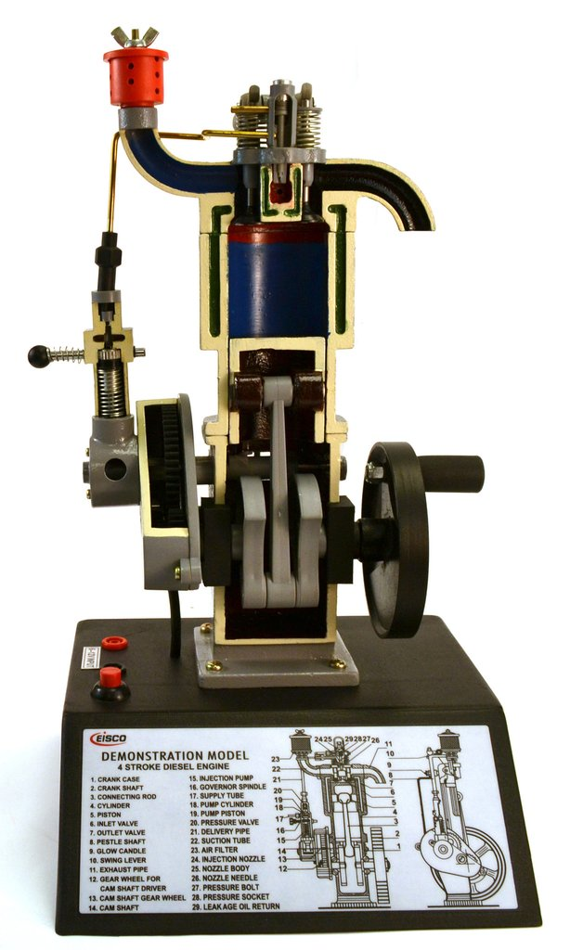In the 1890s, a German inventor, Rudolf Diesel has patented his invention of an efficient, slow burning, compression ignition, internal combustion engine. The original cycle proposed by Rudolf Diesel was a constant temperature cycle. In later years Diesel realized his original cycle would not work and he adopted the constant pressure cycle, which is known as the Diesel cycle. Diesel engines may be designed as either two stroke or four stroke cycles. The four stroke Diesel engine is an internal combustion (IC) engine in which the piston completes four separate strokes while turning a crankshaft. A stroke refers to the full travel of the piston along the cylinder, in either direction. Therefore, each stroke does not correspond to single thermodynamic process given in chapter Diesel Cycle – Processes. Diesel engine, any [internal-combustion engine](https://www.britannica.com/technology/internal-combustion-engine) in which air is [compressed](https://www.britannica.com/science/compressed-air) to a sufficiently high temperature to ignite [diesel fuel](https://www.britannica.com/technology/diesel-fuel) injected into the [cylinder](https://www.britannica.com/technology/cylinder-engineering), where combustion and expansion actuate a [piston](https://www.britannica.com/technology/piston-engineering). It converts the [chemical energy](https://www.britannica.com/science/chemical-energy) stored in the fuel into [mechanical energy](https://www.britannica.com/science/mechanical-energy), which can be used to [power](https://www.britannica.com/science/power-physics) freight trucks, large tractors, locomotives, and marine vessels. A limited number of automobiles also are diesel-powered, as are some electric-power generator sets.

**Figure 1:: Model of four stroke Diesel engine**

The diesel engine uses a four-stroke combustion cycle just like a gasoline engine. The four strokes are **intake stroke, compression stroke, combustion/expansion stroke** and **exhaust stroke.**

**Parts list and details**

Most parts of four stroke diesel engine is similar to four stroke petrol engine except there is **no spark plug** to ignite the air-fuel mixture. It intakes air and compresses it and then injects the fuel directly into the combustion chamber (direct injection). It is the heat of the compressed air that lights the fuel in a diesel engine.

**Fuel Injector:**

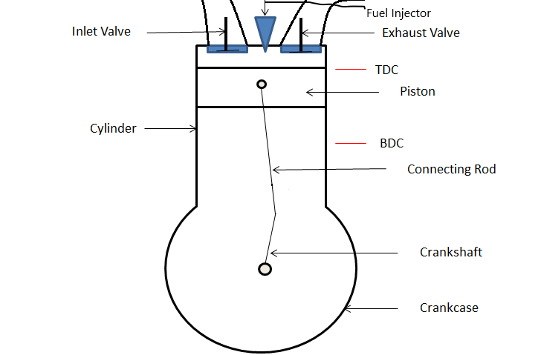One is fitted in the cylinder head for each cylinder and is like a spring-loaded valve. It allows fuel to be sprayed into the cylinder at the precise moment in an atomized form.

**Fuel Injection Pump:**

Can be a multi element type driven by a chain or gears from the crankshaft or camshaft. Each element is connected to a fuel injector. In some engines there is a pump for each cylinder and it is driven off the camshaft. The fuel pump accurately meters the fuel and delivers it under high pressure at a precise moment to the spray nozzle of the fuel injector.

**Heat Plug/Glow Plug:**

Sometimes called glow plugs. One is fitted to each cylinder on pre-combustion chamber engines. They are fitted to assist in the ignition of fuel to start the engine when the engine is cold. Some diesel engines contain a glow plug. When a diesel engine is cold, the compression process may not raise the air to a high enough temperature to ignite the fuel. The glow plug is an electrically heated wire (think of the hot wires you see in a [toaster](https://home.howstuffworks.com/toaster.htm)) that heats the combustion chambers and raises the air temperature when the engine is cold so that the engine can start.

**Figure 2:Labelled diagram of four stroke diesel engine**

**Explanation:**

**Processes:**

The four processes of four stroke diesel engine are given below in following:

* Suction stroke
* Compression stroke
* Power stroke / Expansion stroke
* Exhaust stroke

**Suction Stroke:**

* With the movement of the piston from T.D.C. to B.D.C. during this stroke, the inlet valve opens and the air at atmospheric pressure is drawn inside the engine cylinder; the exhaust valve however remains closed.

**Compression Stroke:**

* The air drawn at atmospheric pressure during the suction stroke is compressed to high pressure and temperature as the piston moves from B.D.C. to T.D.C. Both the inlet and exhaust valves do not open during any part of this stroke.

**Power stroke / Expansion Stroke:**

* As the piston starts moving from T.D.C to B.D.C, the quantity of fuel is injected into the hot compressed air in fine sprays by the fuel injector and it (fuel) starts burning at constant pressure. The fuel is injected at the end of compression stroke but in actual practice the ignition of the fuel starts before the end of the compression stroke. The hot gases of the cylinder expand adiabatically .Thus doing work on the piston.

**Exhaust Stroke:**

* 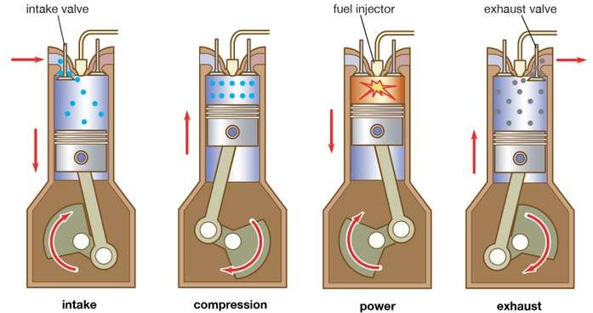The piston moves from the B.D.C. to T.D.C. and the exhaust gases escape to the atmosphere through the exhaust valve. When the piston reaches the T.D.C. the exhaust valve closes and the cycle is completed.

**Figure 3:: Working principle of four stroke diesel engine**

**Graphical Representation:**

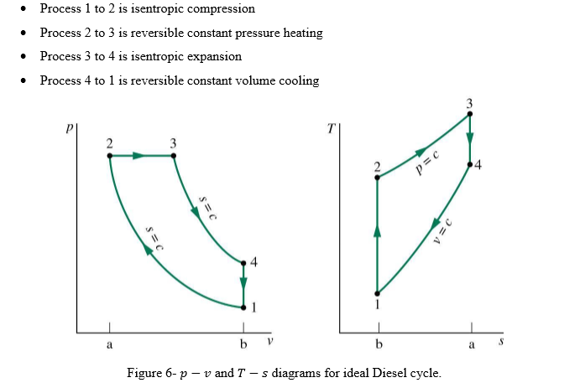

**Figure 4:: Ideal PV and TS diagram for four stroke diesel Engine**

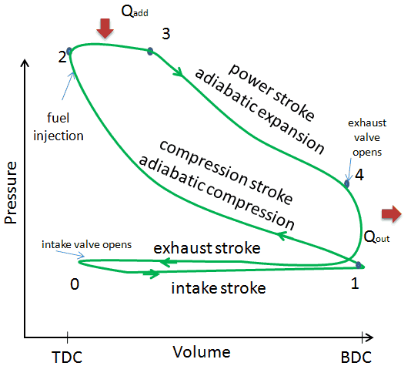

Figure 5:Actual PV diagram of four stroke diesel engine

**Lean Mixture and Rich Mixture**

* The key difference between lean and rich mixture is that we use lean mixture for maximum efficiency and we use rich mixture for maximum power in an engine.
* Lean mixture has more air than the required quantity of air for complete combustion of fuel. It has 24-25 petrol/diesal and 75-76 air.
* On the other hand, rich mixture has less air than the required quantity of air for complete combustion of fuel in engine.

|  |  |
| --- | --- |
| **Advantages of diesel engine** | **Disadvantages of diesel engine** |
| The most important advantage of the diesel engine is that it gets great mileage. It delivers 25 to 30 percent better fuel economy compared to that of similarly performing gasoline engines. The efficiency of the diesel engine is highest and is energy dense fuel. Better fuel economy is delivered by diesel engine than gasoline because it contains more usable energy. The diesel engine has advantage of higher torque compared to petrol powered engine of the same volume. Due to high torque, diesel engine poses an advantage because high torque helps in the city traffic allowing the movement minimal engine turnover in traffic jams. | The cost of diesel engine is almost same or more than that of gasoline. Therefore, it is not cost effective. Due to high cost factor, diesel engine is posing to be as a disadvantage.  Diesel fuel is largely used at homes, for commercial trucks and heating oil. Hence the demand for the diesel engine is growing resulting in increases price of diesel fuel which is more likely continue to rise because of competition from those other users |

**Applications:**

The four-stroke diesel engine has been used in the majority of heavy-duty applications for many decades. It uses a heavy fuel containing more energy and requiring less refinement to produce. The most efficient Otto-cycle engines run near 30% thermal efficiency. They were originally used as a more efficient replacement for stationary steam engines. Since the 1910s they have been used in submarines and ships. Use in locomotives, trucks, heavy equipment and electricity generation plants followed later. Diesel engines in trucks, trains, boats, and barges help transport nearly all products people consume. Diesel fuel is commonly used in public buses and school buses. Diesel fuel powers most of the farm and construction equipment in the United States.

There are several applications of diesel engines and some of them are.

* Diesel generators
* Locomotives
* Farming equipment
* In construction equipment
* In cargo and cruise ships
* In buses and trucks

**Difference**

|  |  |
| --- | --- |
| **Four Stroke Petrol Engine** | **Four Stroke Diesel Engine** |
| * Petrol engine uses spark plug to ignite the fuel-air mixture. * It intakes fuel-air mixture from carburetor during Intake stroke. * It uses petrol as fuel. * The clearance volume during compression is greater. * Efficiency of petrol engine is 25% to 30%. * Petrol engine is less heavy. * Ignition occurs at constant volume. * Petrol engine provides low torque and high speed. * The compression ratio in a gasoline-powered engine will usually not be much higher than 10:1 due to potential engine knocking (autoignition) and not lower than 6:1. * Combustion temperature is nearly 2500 0C and pressure inside cylinder is 100bar during combustion. | * There is no spark plug needed to ignite the fuel. * It intakes only air during intake stroke and then through fuel injector injects diesel in form of spray during compression. * It uses diesel as fuel. * The clearance volume is very less as compared to petrol engine. * Efficiency of diesel engine is 35% to 40%. * Diesel engine is heavier than petrol engine. * Ignition occurs at constant pressure. * Diesel engine provide high torque and low speed. * The Diesel engines have the compression ratio that normally exceed 14:1 and ratios over 22:1 are also common. * Combustion temperature is nearly 500-600C and pressure inside cylinder is 32-50 bar during combustion. |